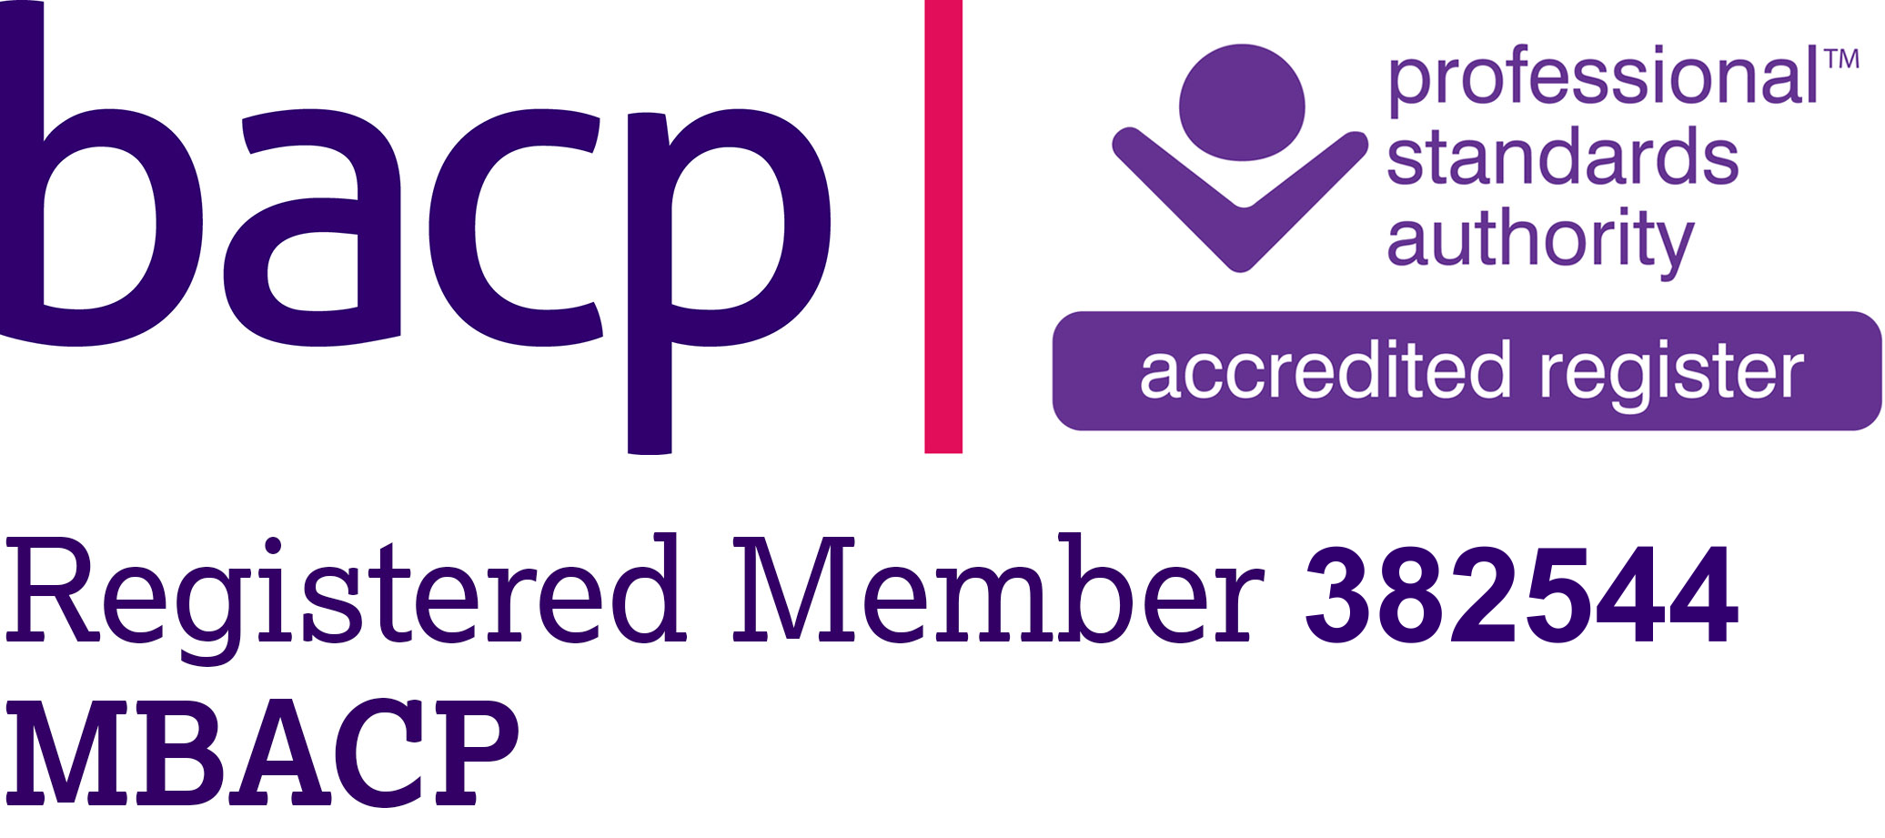

Clarence Firstborn counselling.
Email: c_firstborn@pm.me tel: 07487687460

CONFIDENTIALITY

Everything you say to me is confidential except in specific circumstances where I am legally obliged to disclose information. These circumstances are:

- In response to court orders.

- Prevention of Terrorism Act.

- Drug trafficking and money laundering.

- Serious crime act (2007)
- Includes drug offences
- Immigration and people trafficking offences.
- Sexual offences
- Fraud
- Counterfeiting
- Terrorism
- Violence

- Child protection.

If I felt I would have to make a disclosure I would obtain your consent, only if there was a real risk of serious harm and that risk was imminent; not reducible by the course of therapy or the natural passage of time. I would also have to believe that my breaching of confidentiality would be effective i.e. minimise or prevent the risk or thereat of serious harm.

Client information can be disclosed without the clients consent where the balance of risk is weighed against the benefit to society of the disclosure and the benefits outweigh the risks.

This statement of confidentiality conforms to the BACP’s ethical framework.

